
Individual Report
Big Data Analytics for Business
OIM5015-B

Automation of Jobs across different job sectors and based on the level of education

Sharayu Patil
UB Number- 24035297

- Introduction
Automation: the idea of using technology to reduce human effort was first recorded in 1771 when Richard Arkwright invented the spinning wheel. During the industrial revolution of the 1750s, automation was fully adopted and integrated in the day-to-day functions of the industry to facilitate labour workers and aid productivity. With the increasing integration of artificial intelligence into industrial systems, the landscape of automation is continuously evolving (PALpack, 2022).
The rise of automation is rapidly changing the nature of labour market, replacing jobs and reshaping jobs (Autor, 2015). Frey and Osborne (2017) argue that routine and low-skilled jobs are at a high risk of computerisation in an advanced economy. Developing nations rely heavily on labour-intensive industries as a source of employment. Automation could pose as a challenge, leading to increase in unemployment (Nigar et al., 2025). Therefore, it becomes that much important to determine what factors make it harder for a job to be computerised and what causes a risk of automation. Recent searches show that education and skill development play a role in determining the risk of automation (Hussain, 2024).
This paper discusses the insights provided by literary articles with the use of raw, occupational-level dataset on automation probability by 2030. It evaluates statistical correlation between education level, job category and automation probability.
Aim of this study is to answer these two questions:
- How does the automation probability vary across different job sectors?
- Does attainment of higher education reduce automation probability?
Based on the prior research as supported by literature, these are the proposed hypothesis:
H1- Jobs that require higher level of education have a significantly lower probability of automation.
This is based on the theory that routine and repetitive tasks are at a higher risk of being automated compared to creative tasks that require high-level of skills.
H2- The probability of automation differs significantly across job titles.
This is based on the theory that jobs that require you to study more are safer compared to job that do not, in terms of automation.
This paper aims to apply statistical techniques to real world data related to automation risk rather than relying solely on literature, it uses literature to support hypothesis and findings. It explores quantitative relationship between key variables helps identify patterns and make insights from the literary research and analysis which can be applied in predicting and understanding the economic and labour market research.

2. Methodology
The dataset used for this paper is titled ‘AI Impact on Jobs 2030’ that predicts automation risk across global professions by 2030 uploaded by K. Yadav (2025) on Kaggle. The dataset includes 3000 rows and 20 columns with 3000 observations of 18 variables, including- the automation probability, and level of risk across various occupations with various educational requirements. This dataset it statistically evaluated and visualised to prove established hypothesis using the coding program R.
The key variables used to in this analysis are:
- Job_Title = Name of the occupation, distinguishing the nature of job (Categorical data, discrete data)
- Education_Level = The education requirements of different jobs; High School, Bachelor’s, Master’s, and PhD. (Ordinal, discrete data)
- Automation_Probability_2030 = The probability that the job with be automated by 2030. (Continuous, ratio data type)
- Risk_Category = Classifying job titles into low, medium, high levels of risk. (Ordinal, discrete data)

Since the statistical analysis of this dataset for proving hypothesis requires descriptive evaluation of categorical and numeric data, R’s inbuilt functions were utilised. Descriptive analysis helped measure mean, median, and standard deviation to provide an overview and base further analysis on. The descriptive analysis was cleaned, and the aggregate of variables was used to avoid repetitive observations which can give a clear overview of the dataset
Visualisation techniques like grouped bar chart and diverging horizontal bar chart were used created by R to illustrate the correlation between variables. A pictorial representation of data helps interpretation and identify patterns that are assumed to be supported by literature. These patterns might not be evident from just a summary of the statistics.
The Pearson’s Chi-square test was used to determine correlation between two nominal variables- Education_Level and Risk_Category. This test is appropriate as Chi-square identifies the relationship between two non-numeric and discrete variables using frequency counts. For the second hypothesis, Analysis of Variance (one-way ANOVA) was adopted to facilitate the analysis of one nominal variable- Job_Title and one continuous ratio- Automation_Probability_2030. These variables satisfy the assumptions of ANOVA, which state one variable is dependent while the other is independent.

- Findings
Descriptive Statistics
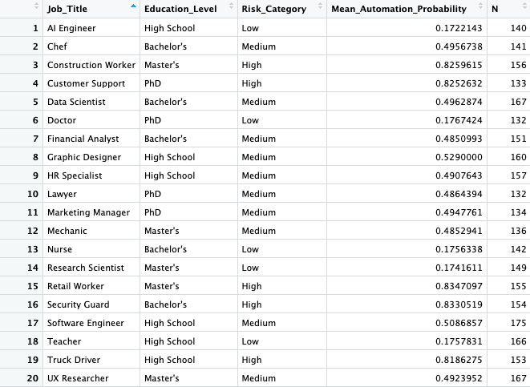
Fig 1.
This is a descriptive statistics table showing 20 observations and 5 variables. N here represents the number of observations of the variable ‘Job_Title.’ This dataset had reoccurring values of job titles with different education level. So, a descriptive aggregate method was used to determine the count of ‘Education_Level’ in terms of the unique value of ‘Job_Title’. Then modal value statistics was used to determine the frequency of the most occurring observation with ‘Job_Title’ by frequency distribution.
The mean of ‘Automation_Probability_2030’ was determined and used as it gives overview of the central tendency of automation, with respect to the job title.

H1- Jobs that require higher level of education have a significantly lower probability of automation.

Variables | P- Value | Cramer's V (adj.)
Education_Level and Risk_Category | 0.84 | 0
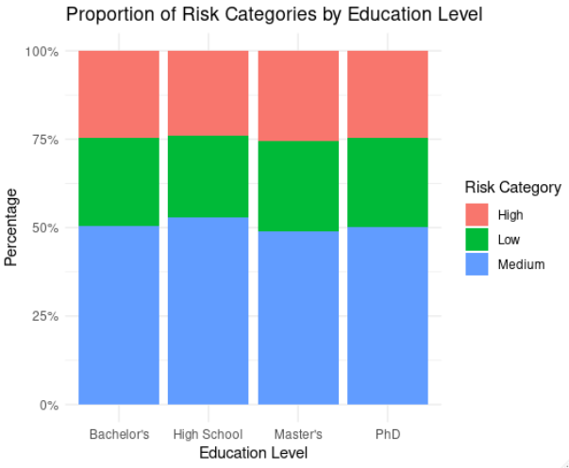
Fig 2.
Above, is a grouped bar plot that visualises the correlation between the level of education and risk category. Based to the result of the Pearson’s Chi-square test, the p-value is <0.05 which fails to reject the null hypothesis.
Null hypothesis- the degree of education does not play any role in reducing automation risk.
Alternative hypothesis- the level of education plays a significant role in reducing automation risk.
The Cramér’s V is the point estimate of association between variables. The value being 0 and the p-value being greater than what is required to reject null hypothesis, clearly shows that there is no correlation between education level and degree of risk.

H2 - The probability of automation differs significantly across job titles.

Variables | P-value | Eta-squared
Automation_Probability_2030 and Job_Title | <2e-16 | 0.86

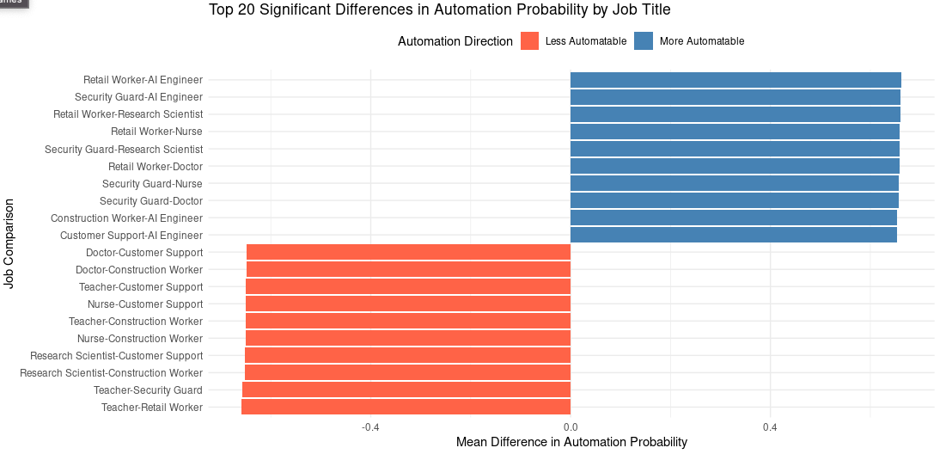
Fig 3.
This is a bar plot illustrating hypothesis 2 that is based on the correlation between Automation_Probability_2030 and Job_Tiltle. It compares the 2 job titles, bar towards left in red signifies the first job is less likely to be automated, while the bar towards right in blue signifies that the first job is more likely to be automated.
To formulate this visualisation, the data was cleaned and shortened. The Tukey HSD post-hoc test helped identify the jobs that differed significantly in their mean automation probability and were limited to the top 20 comparable by magnitude. This was done to facilitate clear visualisation while still providing required and appropriate insights.
Based on the visualisation and the result of the one-way ANOVA test where p-value = <2e-16 <0.05 and the eta-squared being 0.86 meaning, the percentage of the effect independent variable (Job_Title) has on the dependent variable (Automation_Probability_2030) is 86%. This signifies a high correlation and rejection of the null hypothesis.
Null-hypothesis- the probability of automation does not vary across job sectors.
Alternative-hypothesis- the probability of automation varies across job sectors.

- Discussions

Hypothesis 1- Jobs that require higher level of education have a significantly lower probability of automation.
This paper found that there is no significant correlation between education level and risk of automation, which essentially proves against the literary research. As stated by Autor D. (2015a) education has the probability of reducing automation of the job that requires higher learning. His statement was based on United States’ approach to delivering universal high school to all the citizens in the first 4 decades of the 20th centaury (Goldin and Katz 2008). It makes logical sense considering higher education equips you with skills that cannot be automated. This finding challenges the conventional assumptions which shifts the paradigm and implores us to think in a different direction.
Frey and Osborne (2017) argue that higher education helps build cognitive skills that are less likely to be automated, which makes the jobs that require it more secure. However, with the rapid progress of machine learning models that is not the case. Education does not guarantee job security, skills do. As proved by the statistical findings from this dataset, education level and the risk of automation have no relationship. Meaning, a PhD would not assure job security, the skills of an individual that a machine cannot learn will.
Autor D. (2015a) discusses in his article about Polanyi’s paradox, ‘we know more than we can tell’ and how it poses as a limitation for machine learning development. Polanyi established that most tasks that humans perform are ‘tactical’, meaning we know how to do them but cannot build a set of instructions if asked. For example, identifying a table. How do we identify a table? Four legs and a flat surface on top. If these instructions are fed to a computer, it would mistake a chair for a table. That is exactly the gap that intuition fills in. Machine learning has not reached the level of intuition.
Therefore, jobs that require no education and pure skill and knowledge like trading cannot be automated. The market is based on patterns; however, the market is also consciously creating patterns. So, a computer cannot possibly beat the market to make unconventional profits (Daníelsson, Macrae and Uthemann, 2021). Although, a machine learning model could be trained to do the accounts of a company, a job that requires certification.
In a nutshell, the theory that education safeguards the job from automation had grounds previously, but competing against modern technology, it does not.

Hypothesis 2- The probability of automation differs significantly across job titles.
As backed by research, the statistics prove that there is a significant relationship between the probability of automation and the job sector. Routine tasks that involve clear instructions require less innovation can be automated by trained a machine learning model to do it (Frey and Osborne, 2017). Fig 3. Shows a comparison between jobs most likely to be automated and jobs least likely to be automated based on mean automation. In the blue, we can see how jobs like retail worker and security face most threat to automation compared to artificial intelligence engineers and doctors.
As stated previously owing to Polanyi’s paradox, it’s harder to train a computer to perform a task when the human brain cannot ‘tell’ how do to it. Therefore, jobs that require creative thinking are harder to automate. Frey and Osborne (2017), found in their study that jobs like fine arts cannot be taken over by artificial intelligence. As inevitable as it seemed, artificial intelligence algorithms can now create paintings, songs, write books, and make creative videos based on a prompt.
The growth of artificial intelligence and machine learning has been very significant in changing job markets and the industry. The intention of automation has always been to increase productivity and aid labour tasks with efficiency (PALpack, 2022). The counter product of automation is most professions losing their job. Artificial intelligence can now create art, which was never thought possible. Then the argument that certain jobs cannot be automated has no grounds. If machine learning models can be fed enough data about literature to make it fluent and capable of generating book ideas and write books creatively, then it can be fed enough data to diagnose a patient based on their health history and all the knowledge about healthcare.
However, automation has not reached a stage yet where salaried jobs are non-existent. But the job requirements that also contribute to job security have changed. Basic skills, to perform routine and mundane tasks cannot guarantee protection against automation.
There is no perfect way to predict the direction in which artificial intelligence is going to grow and jobs artificial intelligence might take over. But the one variable that stands out in every literature and even in this research is skills. Workers can only benefit out of this if their skills complement automation.
- Conclusion
This paper aimed to find proof of automation probability being influenced by job sector, and education level. Statistics proved that automation probability varies across job categories however is independent of the level of education the job requires. Analysing a dataset downloaded from Kaggle, this paper attempted to prove two hypothesis, supported by literature and this is what was found:
- Artificial intelligence and automation pose as a threat to even the jobs that require high levels of education, defying past literary theories of Hussain (2024) and Frey and Osborne (2017) in light of modern technology.
- The jobs most threatened by automation are the jobs that are easier to do. Jobs with minimum level of skill can easily be substituted by computers which prove to be more accurate and efficient than humans.
This research still has limitations. The data used is cross-sectional, meaning that observations are taken at a single point of time; which makes the observation of changing over-time invalid and cannot establish direction of evaluation. It is therefore not possible to state that the statistical findings from this report are the truth. To determine exact results, data collected over a period of time should be analysed to identify a pattern.

Reference list
Autor, D. (2015a). Why Are There Still So Many Jobs? The History and Future of Workplace Automation †. [online] ResearchGate. Available at: https://www.researchgate.net/publication/282320407_Why_Are_There_Still_So_Many_Jobs_The_History_and_Future_of_Workplace_Automation.
Autor, D.H. (2015b). Why Are There Still so Many Jobs? the History and Future of Workplace Automation. Journal of Economic Perspectives, 29(3), pp.3–30. doi:https://doi.org/10.1257/jep.29.3.3.
Bentaouet Kattan, R., Macdonald, K. and Patrinos, H.A. (2020). The Role of Education in Mitigating Automation’s Effect on Wage Inequality. LABOUR, 35(1), pp.79–104. doi:https://doi.org/10.1111/labr.12187.
Daníelsson, J., Macrae, R. and Uthemann, A. (2021). Artificial intelligence and systemic risk. Journal of Banking & Finance, [online] 140(140), p.106290. doi:https://doi.org/10.1016/j.jbankfin.2021.106290.
Field, A. (2024). Discovering Statistics Using IBM SPSS Statistics. 6th ed. Los Angeles: Sage Publications.
Frey, C.B. and Osborne, M.A. (2017). The Future of Employment: How Susceptible Are Jobs to Computerisation? Technological Forecasting and Social Change, [online] 114(1), pp.254–280. doi:https://doi.org/10.1016/j.techfore.2016.08.019.
Hatcher , L. (2013). Advanced Statistics in Research: reading, understanding, and writing up data analysis results .
Hussain, M.A. (2024). The Impact of Artificial Intelligence on Workforce Automation and Skill Development. Journal of Artificial Intelligence,Machine Learning and Neural Network (JAIMLNN) ISSN: 2799-1172, [online] 4(04), pp.11–21. doi:https://doi.org/10.55529/jaimlnn.44.11.21.
Nigar, M., Juli, J.F., Golder, U., Alam, M.J. and Hossain, M.K. (2025). Artificial intelligence and technological unemployment: Understanding trends, technology’s adverse roles, and current mitigation guidelines. Journal of Open Innovation: Technology, Market, and Complexity, [online] 11(3), p.100607. doi:https://doi.org/10.1016/j.joitmc.2025.100607.
PALpack (2022). The automation of the manufacturing process | PALpack. [online] PALpack. Available at: https://www.palpack.co.uk/news/the-automation-of-the-manufacturing-process/.

Appendix:
R code of Hypothesis 1 and 2, descriptive statistics
H1 R Code-
install.packages (“gmodels”)
library (gmodels)
CrossTable(data$Education_Level, data$Risk_Category, expected = T, prop.r = F, prop.c = T, prop.t = F, chisq = T, format = "SPSS")
install.packages("effectsize")
library (effectsize)
tab <- table(data$Education_Level, data$Risk_Category)
cramers_v(tab)
ggplot(data, aes(x = Education_Level, fill = Risk_Category)) +
+ geom_bar(position = "fill") +
+ scale_y_continuous(labels = scales::percent_format()) +
+ labs(
+ title = "Proportion of Risk Categories by Education Level",
+ x = "Education Level",
+ y = "Percentage",
+ fill = "Risk Category"
+ ) +
+ theme_minimal()

H2 R Code-
aov(Automation_Probability_2030 ~ Job_Title, data = data)
anova_result <- aov(Automation_Probability_2030 ~ Job_Title, data = data)
summary(anova_result)
library(effectsize)
eta_squared(anova_result)
install.packages (ggplot2)
library(ggplot2)
TukeyHSD(anova_result)
sig_tukey <- subset(tukey_df, `p adj` < 0.05)
head(sig_tukey, 20)
top_diff$color <- ifelse(top_diff$diff > 0, "More Automatable", "Less Automatable")
ggplot(top_diff, aes(x = reorder(Comparison, diff), y = diff, fill = color)) + geom_col() + coord_flip() + scale_fill_manual(values = c("More Automatable" = "steelblue", "Less Automatable" = "tomato")) + labs(...) + theme_minimal() + theme(legend.position = "top")

Descriptive Statistics –
install.packages (“dplyr”)
library (dplyr)
final_descriptive_table <- data %>%
+ group_by(Job_Title) %>%
+ summarise(
+ Education_Level = names(which.max(table(Education_Level))),
+ Risk_Category = names(which.max(table(Risk_Category))),
+ Mean_Automation_Probability = mean(Automation_Probability_2030, na.rm = TRUE),
+ N = n(),
+ .groups = "drop")

